**j. Groom Wedding collection**

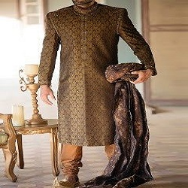

**GOLDEN BROWN SHIRWANI WITH TURBAN**

PKR34.000.00

* Shirwani size: Medium
* Pajama: 2.5 Meters

**MORE INFORMATION:**

* color: Golden and BROWN
* Wear Type: Wedding
* Product Category: Groom shirwani
* Volume : Volume 4 2022
* Collection: Festive Affair '22
* Sizes: Smal, Medium , large
* Fabric: Banarsi
* Size: S , M , L ,XL
* Disclaimer: Due to the photographic lighting & different screen calibrations, the colors of the original product may slightly vary from the picture